**Diwali Sales Analysis – EDA Project Report**

**Project Title: Exploratory Data Analysis on Diwali Sales Dataset**

**Objective:**

This project focuses on uncovering purchasing patterns and customer behaviors during the Diwali season. By analyzing transactional data, the goal is to provide insights into demographics, product preferences, and high-performing segments to support targeted marketing and sales strategies.

**Tools & Technologies Used:**

* **Python** (Pandas, NumPy)
* **Data Visualization:** Matplotlib, Seaborn
* **Jupiter Notebook** for interactive exploration

**Dataset Overview:**

* Imported dataset: Diwali Sales Data.csv
* Initial shape: Verified using df.shape
* Data previewed using df.head() and structure examined using df.info()
* Cleaning steps:
  + Null values dropped using dropna()
  + Columns Amount converted to numeric data type

**Key Visualizations & Insights:**

1. **Gender Distribution**
   * **Chart:** sns.countplot(x='Gender')
   * **Insight:** Female customers slightly outnumber males.

1. **Total Amount by Gender**
   * **Chart:** Barplot on grouped sum of Amount by Gender
   * **Insight:** Despite fewer male transactions, **males contribute a higher total purchase amount**.

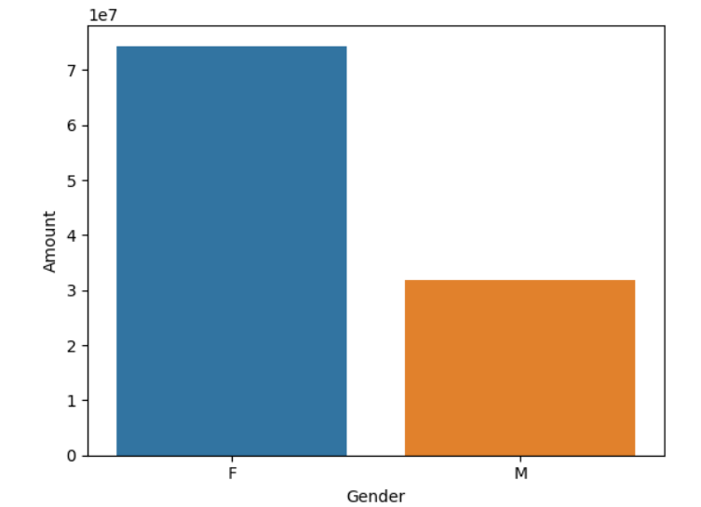

1. **Age Group Distribution**
   * **Chart:** sns.countplot(x='Age Group')
   * **Insight:** The **26–35 age group** dominates in customer count.

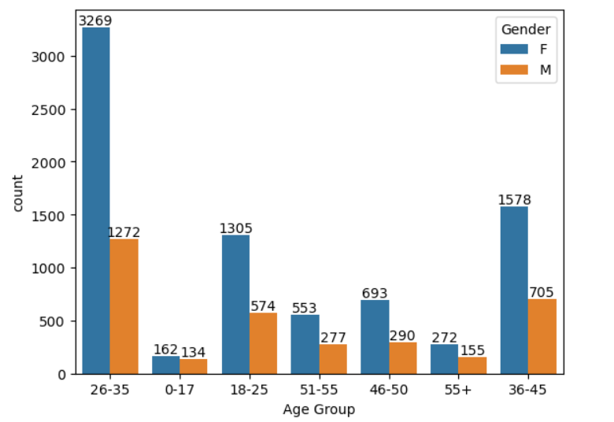

1. **Total Amount by Age Group**
   * **Chart:** Barplot of Amount grouped by Age Group
   * **Insight:** The **26–35 segment also generates the highest revenue**, indicating a key demographic.

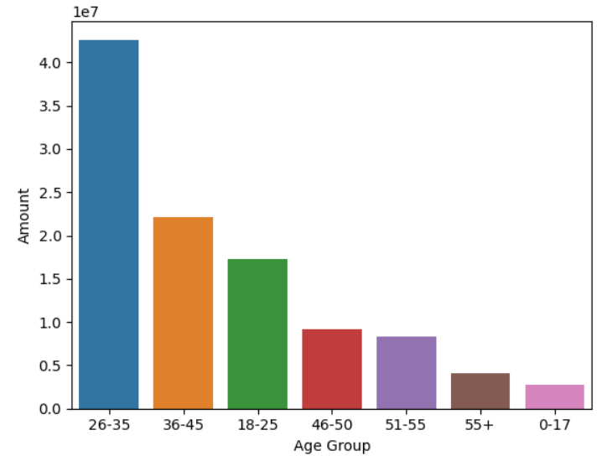

1. **Age Group vs Gender Breakdown**
   * **Chart:** Stacked countplot using hue='Gender'
   * **Insight:** Males dominate spending in most age brackets.

1. **State-wise Customer Distribution**
   * **Chart:** sns.countplot(x='State')
   * **Insight:** **Maharashtra**, **Karnataka**, and **Uttar Pradesh** lead in transaction count.
2. **Total Revenue by State**
   * **Chart:** Horizontal barplot grouped by Amount
   * **Insight:** **Uttar Pradesh** contributes the most to total revenue.
3. **Marital Status Distribution**
   * **Chart:** Countplot for Marital_Status
   * **Insight:** Unmarried individuals shop slightly more,

1. **Marital Status vs Spending**
   * **Chart:** Barplot grouped by Marital_Status
   * **Insight:** **Married individuals contribute more to total revenue**.

1. **Occupation Analysis**

* **Charts:** Countplot and grouped barplot on Occupation
* **Insight:** **IT Sector and Healthcare professionals** dominate both in count and purchase power.

1. **Product Category Performance**

* **Chart:** Countplot and revenue barplot by Product_Category
* **Insight:** **Food, Clothing, and Electronics** are the top categories.

1. **Top 10 Products by Sales**

* **Chart:** Horizontal barplot of top-selling Product_IDs by Amount
* **Insight:** Indicates highly popular products to be prioritized in stock and promotion.

**Business Recommendations:**

* Focus marketing campaigns on the **26–35 age group**, especially males in high-spending states.
* Design personalized offers for **married professionals in IT and Healthcare** sectors.
* Promote **Food, Clothing, and Electronics** heavily during festive seasons.
* Allocate inventory and discounts on **top-selling product IDs**.

**Conclusion:**

This Diwali Sales Analysis demonstrates how structured EDA using Python and visualization libraries can reveal valuable consumer insights. It highlights key segments, regions, and products to target for maximizing seasonal sales and improving customer engagement.

This project showcases my ability to clean, explore, visualize, and derive actionable recommendations using real-world retail data.